**May 2025**

SERVICE IMPROVEMENT OFFICER

**Job Pack**



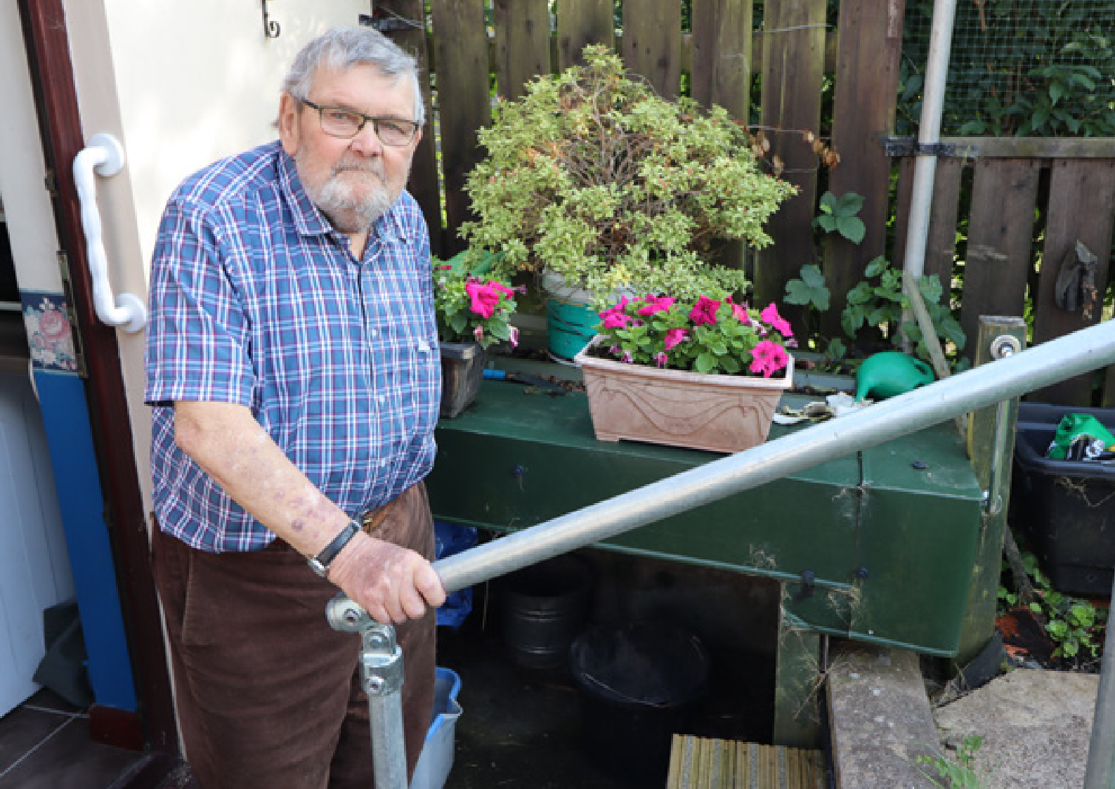

CROESO

Thank you for your interest in joining Care & Repair Cymru.

We are a passionate, driven, and dedicated organisation that works tirelessly to ensure older people across Wales have homes that are safe, warm, and fit for their needs.

Every year, we support over 40,000 households, preventing unnecessary hospital admissions, reducing pressure on the NHS, and most importantly, transforming lives.

Care & Repair Cymru is at the heart of a movement that champions older people’s housing needs. We lead and support local Care & Repair Agencies, drive service innovation, secure vital funding, and influence government policy to bring real, lasting change.

Our work ensures that older people’s voices are heard and that their homes enable—not hinder—their independence.

By joining us, you become part of a team that is making a real difference. Whether through policy and advocacy, or strategic support, every role at Care & Repair Cymru contributes to a Wales where older people can live independently in homes that meet their needs.

We’re looking for talented, compassionate individuals who share our vision and commitment. We welcome enquiries from everyone and value diversity in our workforce. If you’re passionate about social impact and want to make a difference, you’ve come to the right place.



**Chris Jones**Chris Jones

Chief Executive

ABOUT US

**Care & Repair helps older people in Wales to repair, adapt and maintain their homes.**

We are a Wales-wide charitable movement, working to ensure all older people can live independently in safe, warm, and accessible homes.

We support over 40,000 households in Wales each year, preventing thousands of hospital admissions and saving the Welsh NHS over £30m annually.

Our Vision

A Wales where all older people can live independently in safe, warm and accessible homes.

The Care & Repair Movement

Care & Repair in Wales consists of

Care & Repair Cymru and 13 Care & Repair Agencies. Covering every

corner of Wales, the Care & Repair Agencies deliver our services face-to-face with older people. Care & Repair Cymru is the national body providing expertise, advocacy and resources.

Care & Repair Cymru

CRC is the national voice of the Care & Repair Movement. We represent and support Care & Repair Agencies and seek increased investment to improve older people’s housing. We champion and articulate the housing needs of older people using our own evidence and working in partnership with others to influence improved government policy.

**NOTE**: This job pack is for vacancies at Care & Repair Cymru only.   
If you are applying for a role at a local Care & Repair Agency please contact them directly for a different job pack.

OUR VALUES

Inclusive   
Equality is important to us as a team. We recognise and value peoples’ diversity, their differences and their strengths in an equal way.

Passionate   
We care about all our customers, about the quality of our services, about our reputation, about each other. We love what we do and are committed to making a difference. We take responsibility for our actions.

Supportive   
We believe in listening, helping and encouraging each other. We respect all ideas and opinions. We are honest, open, transparent and trust each other. We provide

opportunities for people to develop and flourish. We give freedom to do the job and know that mistakes are part of learning and getting better.

Creative   
We are innovative, agile, respond positively to change and opportunity and thrive in a flexible working environment that encourages creativity. We strive to make our dreams a reality.

Celebrate & Have Fun   
We believe in a relaxed working environment with freedom and flexibility that creates positive energy, enjoyment and helps us meet the challenges we face as a Team. We celebrate in our success.

JOB

DESCRIPTION

Service Improvement Officer

**Salary:** £34,180

**Reports to:** Head of Policy & Insights

**Responsible for:** No direct reports.

**Based**: Care & Repair Cymru Offices, Cardiff. Hybrid Working Policy in place**.**

**Contract:** Permanent

**Hours:** Full Time – 35 hours per week

**Key Contacts:**

CRC SMT and staff team, C&R Agency Chief Officers and staff, local strategic partners (housing, health, social care, fuel poverty, energy efficiency and third sector), academic contacts relating to research and development, other contacts relevant to service improvement, policy and influencing work.

**5**

Main Purpose

The Policy and Insights Team deliver CRCs policy and research aims and objectives, gather data to evaluate Care & Repair services and impact, and work with Care & Repair Agencies on sharing good practice, innovation and best service delivery models.

Based in the Policy and Insights Team, this post will:

* provide expertise in best practice models for housing adaptations and other services.
* contribute to Care & Repair service evaluation, best practice support and development, research and policy influencing, and help maintain a strong profile among policy makers, partners and stakeholders.

Key Tasks

* Undertake research, policy and good practice development work to improve housing adaptation services across Care & Repair; including Rapid Response Adaptations (RRAP), Disabled Facilities Grants (DFG), Enable and other housing adaptation programmes.
* Highlight the housing needs of older people, service gaps and appropriate housing adaptation service solutions to meet those needs, through mixed-method research to include desk based, primary research, client insights, and analysing data from the Care & Repair database. Provide reports, information, articles and regular updates on those findings.
* Monitor and analyse the changing Welsh, UK and wider policy environment relevant to older people and housing adaptations and their use and impact across Housing, health, and social care.
* Work closely with the Head of Policy and Insights, wider Care & Repair Cymru and Care & Repair Agencies to identify best practice, new technology, effective service delivery models and innovation across all our services.
* Develop best practice guides, Housing Adaptation staff Networks and other methods of sharing and replicating good practice across Wales.
* Prepare reports and written briefings for CRC senior managers, CRC Board of Trustees, Care & Repair Agencies and wider stakeholders, to ensure they are kept informed and updated on service improvement findings, recommendations, and proposals to replicate across Care & Repair.
* Engage with the Welsh Government Health and Housing team to share information that may need to feed into any adaptations reviews ongoing from time to time.
* Attend and represent CRC at policy, research and service improvement events including Cross Party Groups, third sector alliance meetings, inquiries, seminars, workshops and Conferences.
* Identify and develop good working relationships and strategic partnerships with relevant organisations, networks and individuals involved in housing adaptation services across Care & Repair, Housing, Health, Social Care and the third sector.
* Prepare Care & Repair Cymru responses to Welsh Government and UK Government policy, legislation and other consultations, working closely with Care & Repair Agencies to ensure key service issues and impacts on older people are included.
* Provide clear, concise, contemporary content relating to the work of this role, for internal and external publications including website, social media, print media, briefing papers, press releases, leaflets, fact sheets etc.

General Duties

* To provide timely, high quality CRC Board, Committee and Steering Group reports.
* To drive innovation and best practice in service delivery and help develop innovative ideas into viable services that can be delivered on the ground across Care & Repair Agencies.
* To promote values, ethos, and standards of Care & Repair Services
* To represent the organisation in a professional and ethical manner.
* To be fully informed about relevant policy and current affairs.
* To maintain excellent relationships with officials, politicians, partners, and stakeholders.
* To maintain excellent relationships with C&R Agencies, C&R Agency Boards and all other relevant contacts and partners.
* Any other duties the Head of Policy and Insights and Chief Executive requests to be undertaken.
* Travel across Wales and the United Kingdom with occasional overnight stays will be part of the working practice.
* Work in accordance with the organisation’s policies, including Hybrid Working, Equal Opportunities and the Welsh Language Scheme.

BENEFITS OF WORKING WITH US

* 25 days annual leave (pro rata) – increasing by 1 day for each completed years’ service, for first 5 years.
* 4 extra paid days off during the festive break (pro rata)
* 5 paid volunteering days (pro rata)
* Flexible working
* Hybrid working policy
* EV salary sacrifice scheme
* Employer-provided health plan
* Accessible, modern offices with free parking

HOW TO APPLY

**Download our job application form:**[**Job Application Pack**](https://careandrepair.org.uk/wp-content/uploads/2025/04/CRC-Job-Application-Pack.docx) **All completed applications should be sent to:**[**adrian.lister@careandrepair.org.uk**](mailto:adrian.lister@careandrepair.org.uk)

PERSON SPECIFICATION

**8**

|  |  |
| --- | --- |
| Criteria | Necessary Requirements |
| **Essential Experience** | * Good track record in policy and research or service improvement in housing, health, social care, and/or the third sector * Undertaking research and policy development/ service improvement * Influencing policy development and/or service improvement * Producing written reports, media content and presentations * Collaborative working * Influencing change * Managing multiple tasks flexibly * Delivering to deadlines * Working with ICT including Microsoft applications e.g. Word, Excel, PowerPoint, Outlook, Co-pilot |
| **Essential Knowledge** | * Knowledge of the housing needs of older people, including housing adaptation services * Knowledge of research and policy development methods * Knowledge and understanding of the links between housing, social care and health * Knowledge of Welsh public policy development frameworks and influencing opportunities * Knowledge of the third sector in Wales/UK |
| **Essential Skills** | * Strong influencing and public affairs skills * Strong research and policy development * Highly motivated self-starter * Creative and strategic thinker * Proactive, can-do approach * Ability to present complex information clearly * Excellent written skills * Confident communicator * Good presentation skills * ICT skills including Microsoft applications e.g. Word, Excel, PowerPoint, Outlook, Co-pilot * Well organized, excellent time management * Working in a pressured environment and to deadlines * Excellent digital and social media skills * Able to build effective relationships * Supportive team player interested in contributing to shared goals * Political awareness * Strong understanding and commitment to equalities |
| **Other essential** | * Reliable, organised and professional * Full driving license * Able/willing to work occasional evenings/weekends if required * Able and willing to travel within UK |
| **Desirable** | * Knowledge of current Care & Repair projects and ambitions for service improvement. * Speaking at events, seminars, conferences and Board meetings. * Ability to speak and write in Welsh. * Experience using Power Bi. |

TERMS AND CONDITIONS

|  |  |
| --- | --- |
| **Employer** | Care & Repair Cymru |
| **Job Title** | Service Improvement Officer |
| **Location** | Mariners House, East Moors Road, Cardiff, CF24 5TD  Hybrid Working Policy in place, with a mix of 2 days office based (option to work more days in office), and 3 days home based. |
| **Salary** | £34,180 |
| **Hours** | 35 hours per week |
| **Holidays** | 25 days (pro rata), rising by one day for each completed year of service, to a maximum of 30 days.  All public holidays plus 4 additional days leave during Christmas and New Year holidays. |
| **Flexi Time** | Flexible working. Work between 7am – 7pm with no core hours. |
| **Cash Health Plan** | Paid for cash health plan (Simply Health). |
| **Pension** | Defined Contribution Scheme  3.8% Employer  5% Employee, but additional contributions can be made. |
| **Learning and Development** | We are a Trusted Charity and support our team with training and development for job proficiency, personal and career development. |
| **Offices** | Modern offices with free onsite car park. |

www.careandrepair.org.uk

enquiries@careandrepair.org.uk

029 2010 7580

Care & Repair Cymru is a registered charity (No. 1163542)

and a company limited by guarantee (No. 09574555).