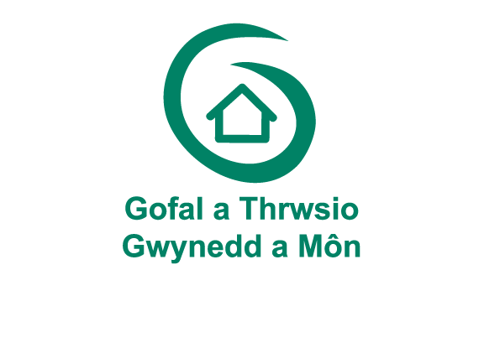

Privacy Policy

This Privacy policy explains how Gofal a Thrwsio Gwynedd a Mon store and use any personal information we collect.

Gofal a Thrwsio Gwynedd a Mon is a service managed by Canllaw (Eryri) cyf, a limited company by guarantee : 3699768.
Registered Charity no : 1075667 registered in Wales

About us
Care and Repair is a charity that actively works to ensure that all older people have homes that are safe, secure and appropriate to their needs. We assists older people to repair, adapt and maintain their homes so they can stay living independently in their own homes. Our service is person centred and tailored to each individual’s needs by providing advice and practical support on a range of issues.
As the older people’s Housing champion, we have delivered, evolved and innovated services that have helped older people for over 30 years. We work with a wide range of local and national partners including Welsh Goverment, Local Authorities , Health Boards and Department of Work and Pensions.
There are many ways you can contact us, including by phone, email and post.
Our address is :
Gofal a Thrwsio Gwynedd a Mon
Uned 8/9
Llys y Fedwen
Parc Menai
Bangor
Gwynedd
LL57 4BL

Telephone number: 0300 111333
We have a Data Protection Officer and you can contact him at gofalathrwsio@gofalathrwsio.org or via our postal address Please mark the envelope ‘Data Protection Officer’.

Changes to this privacy policy
We may change this privacy notice from time to time by updating this page in order to reflect changes in the law and/or our privacy practices. We encourage you to check this privacy notice for changes whenever you visit our website.

What is the General Data Protection Regulation?
The General Data Protection Regulation (GDPR) is a legal framework that sets guidelines for the collection and processing of personal information of individuals within the European Union (EU) which came into force on the 25th May 2018.
A processor of personal data must clearly disclose any data collection, declare the lawful basis and purpose for data processing, how long data is being retained, and if it is being shared with any third-parties or outside of the EU

Why do we collect your personal data?
Most of the personal data we collect is provided to us directly by you for one of the following reasons:
- You have made a request to us for one of our services.
- A member of your family has made an enquiry to us on your behalf
- You have made an information request to us.
- You wish to attend, or have attended, an event.
- Any other specific purposes that you may have agreed to.
We also receive personal information indirectly from third parties such as the local authorities, health boards, goverment agencies and other organisation with a request to provide you with one of our services.

What personal data do we collect about you?
- Personal and contact details, such as title, full name, contact details
- Your date of birth, gender and/or age
- Your nationality, if relevant
- Family members, if relevant
- Records of your contact with us, if and when you get in touch with us
- Information about your health, if relevant
- Information about your property, if relevant
- Your financial information, if relevant
- Information about your property occupier status, such as whether you are a tenant, live with parents/children or are an owner-occupier of the property where you live.
- Your marital status, family, lifestyle or social circumstances, if relevant
- Third party authority, such as where a person other than you has authority to discuss matters on your behalf.
- Any other information required for the purpose of providing you with our services

What do we use you personal data for?
Your details are required in order for us to provide you with our services.
We will use your non-sensitive personal data to
- register you as a new client
- manage payment
- collect and recover monies owed
- to manage our relationship with you
- send you details of our goods and services
What are our lawful basis for processing your personal information?

Our lawful basis for processing your data in relation to points (I) to (iv) is necessary for the performance of a contract with you and in relation to (iii) and (v) is necessary for our legitimate interests of providing a service, develop products, grow our business and recover any monies owed.

Any sensitive personal data we collect from you is for the purposes of providing our services to you or if we need to comply with a legal obligation. Our legal ground of processing this data is your explicit consent.

Who do we share your personal data with?
We require all of the third parties to whom we transfer your data to respect the security of your personal data and to treat it in accordance with the law.
We may have to share your personal data with

- service providers who provide IT and system administration support
- professional advisors including lawyers, bankers, auditors and insurers
- HMRC and other regulatory authorities
- Recognising Excellence – who manage the AQS process
- third parties to whom we sell, transfer or merge parts of our business or our assets
- GP’s, Department of Works and Pensions, Local Authorities, charities and landlords
- Any other professionals/professional bodies for the purpose of our service to you

In any scenario, we will satisfy ourselves that we have a lawful basis on which to share the information, document our decision making and satisfy ourselves we have a legal basis on which to share the information.
We will not share your information with any third parties for the purposes of direct marketing

How long will we keep your data?

We will only keep your personal data for as long as is necessary to fulfil the purposes for which we collected it. We may retain your data to satisfy any legal, accounting, or reporting requirements so for example we need to keep certain information about you for 6 years after you cease to be a client for tax purposes. You have the right to ask us to delete the personal data we hold about you in certain circumstances.

Data security

We have put in place security measures to prevent your personal data from being accidentally lost, used or accessed in an unauthorised way, altered or disclosed. We also limit access to your personal data to those employees, agents, contractors and other third parties who have a business need to know such data. They will only process your personal data on our instructions and are subject to a duty of confidentiality. We have procedures in place to deal with any suspected personal data breach, and will notify you and any applicable regulator where we are legally required to do so.

Your rights under GDPR
You are able to exercise certain rights in relation to your personal data. Below is a brief list of your rights. For a detailed explanation, please visit
https://ico.org.uk/for-organisations/guide-to-the-general-data-protection-regulation-gdpr/individual-rights/

The right to be informed
You have the right to be informed about the collection and use of your personal data. This policy and any other supporting statements/communications are intended to provide you with a clear and transparent description of how your personal information is used.
The right of access
You have the right to obtain a copy of your personal data as well as other supplementary information. This can be done by request to the DP Officer. We will not charge a fee for responding to this request unless your request is clearly unfounded, repetitive or excessive in which case we may charge a reasonable fee or decline to respond.
We will, in most cases, reply within one month of the date of the request unless your request is complex or you have made a large number of requests in which case we will notify you of any delay and will in any event reply within 3 months.

If you wish to make a Subject Access Request, please send the request to-

Data Protection Officer
Canllaw (Eryri) Cyf
Uned 8/9
Llys y Fedwen
Parc Menai
Bangor
Gwynedd
LL57 4BL

Alternatively, email gofalathrwsio@gofalathrwsio.org marked for the attention of the Data Protection Officer.
The right to rectification
You have a right to have your personal information corrected if it is inaccurate. We have a duty to keep your personal data up to date and accurate so from time to time we will contact you to ask you to confirm that your personal data is still accurate and up to date.

If there are any changes to your personal data, such as a change of address, please let us know as soon as possible by writing to or emailing the addresses above

The right to erasure
Under Article 17 of the GDPR you have the right to have personal data erased. This is also known as the ‘right to be forgotten’. The right is not absolute and only applies in certain circumstances.
The right to restrict processing
This means that you can limit the way that an organisation uses your data if there is a disagreement about its accuracy or you are questioning whether our use is legitimate or not. This is an alternative to requesting the erasure of your data
The right to data portability
The right to data portability gives you the right to receive personal data you have provided to a us in a structured, commonly used and machine readable format. It also gives you the right to request that we transmit this data directly to another controller
The right to object
The right to object only applies in certain circumstances. Whether it applies depends on our purposes for processing and our lawful basis for processing.
Rights in relation to automated decision making and profiling.
Automated individual decision-making is a decision made by automated means without any human involvement. At present we do not use this process but if at any time in the future we decide that our processes will involve automated decision making or profiling we will give you specific information about that process.

Complaints
We are committed to protecting your personal data but if for some reason you are not happy with any aspect of how we collect and use your data, you have the right to complain to the Information Commissioner’s Office (ICO), the UK supervisory authority for data protection issues (www.ico.org.uk).

We would be grateful if you would contact us first if you have a complaint so that we can try to resolve it for you.

